Management levels and hierarchy

Friday, October 18, 2024

03:39

Azure provides four levels of management: management groups, subscriptions, resource groups, and resources. The following diagram shows the relationship between these levels.

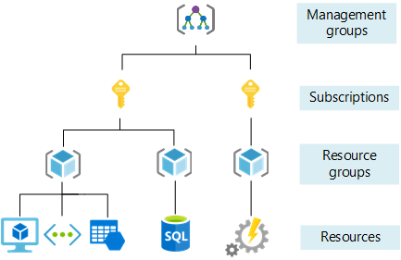

* Management groups help you manage access, policy, and compliance for multiple subscriptions. All subscriptions in a management group automatically inherit the conditions that are applied to the management group.
* Subscriptions logically associate user accounts with the resources that they create. Each subscription has limits or quotas on the amount of resources that it can create and use. Organizations can use subscriptions to manage costs and the resources that are created by users, teams, and projects.
* Resource groups are logical containers where you can deploy and manage Azure resources like virtual machines, web apps, databases, and storage accounts.
* Resources are instances of services that you can create in a resource group, such as virtual machines, storage, and SQL databases.